Lab 4: Install Docker & Gitea

1. Objectives
This lab aims to install and configure Docker Desktop and Gitea on macOS, verify Large File Storage (LFS) functionality, and perform repository operations including uploading a large file, creating a course repository, backing up data, and installing Gitea without Docker.

2. Environment
Operating System: macOS Sequoia 15.7.1
Hardware: MacBook Air M4 (arm64)
Tools: Homebrew, Docker Desktop, Gitea (Docker & native), Git LFS

3. Procedures and Screenshots

Step 1: Install Docker Desktop
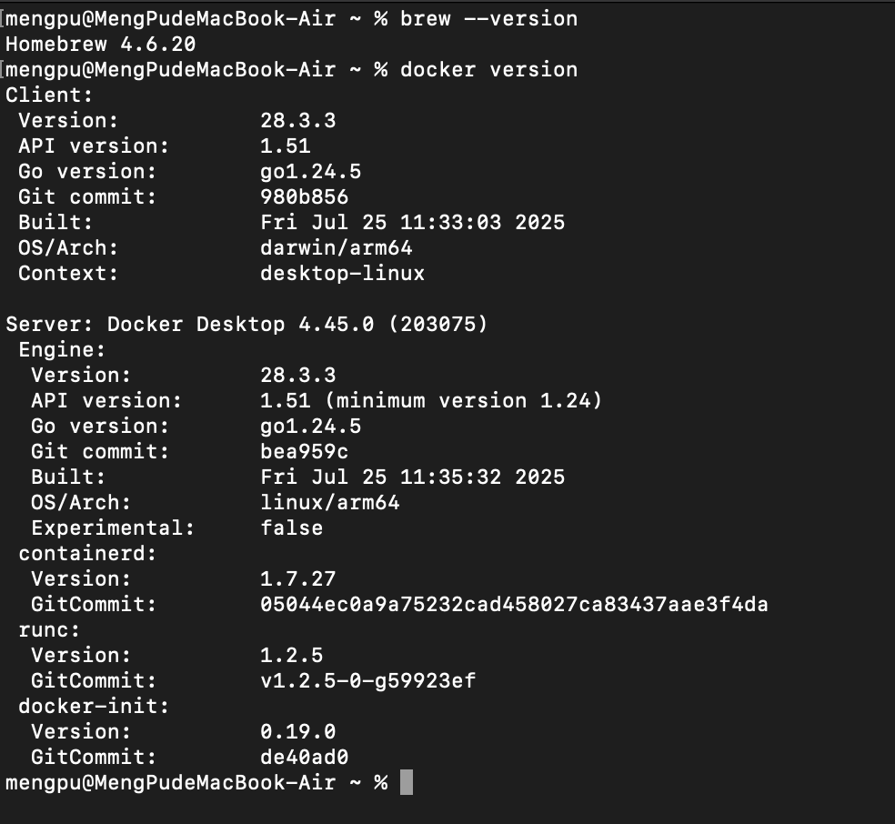
Docker and Homebrew installation verification on macOS.
This step installs Docker Desktop using Homebrew and verifies the installation. The commands confirm successful installation and version compatibility.

Step 2: Deploy Gitea using Docker
Created docker-compose.yml and used Docker Compose to pull and start the Gitea container.
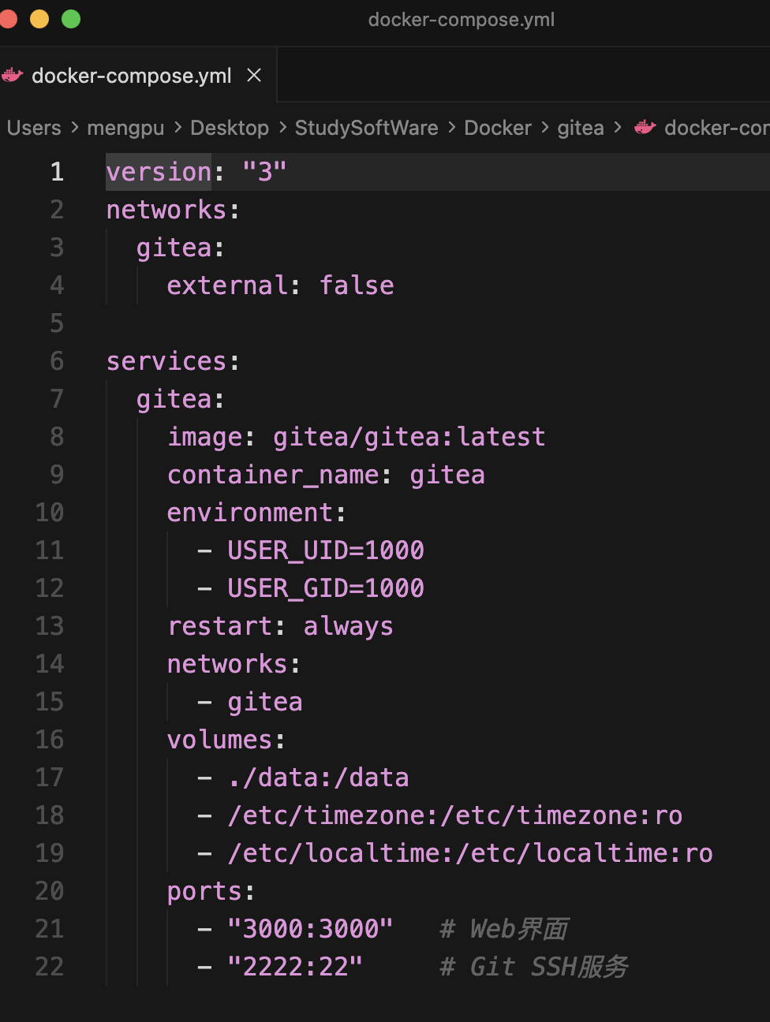
Docker Compose YAML configuration for Gitea deployment.
The docker-compose.yml file defines the Gitea service, ports, and persistent volumes. The configuration ensures Gitea runs with SQLite3 as database and exposes ports 3000 and 2222.
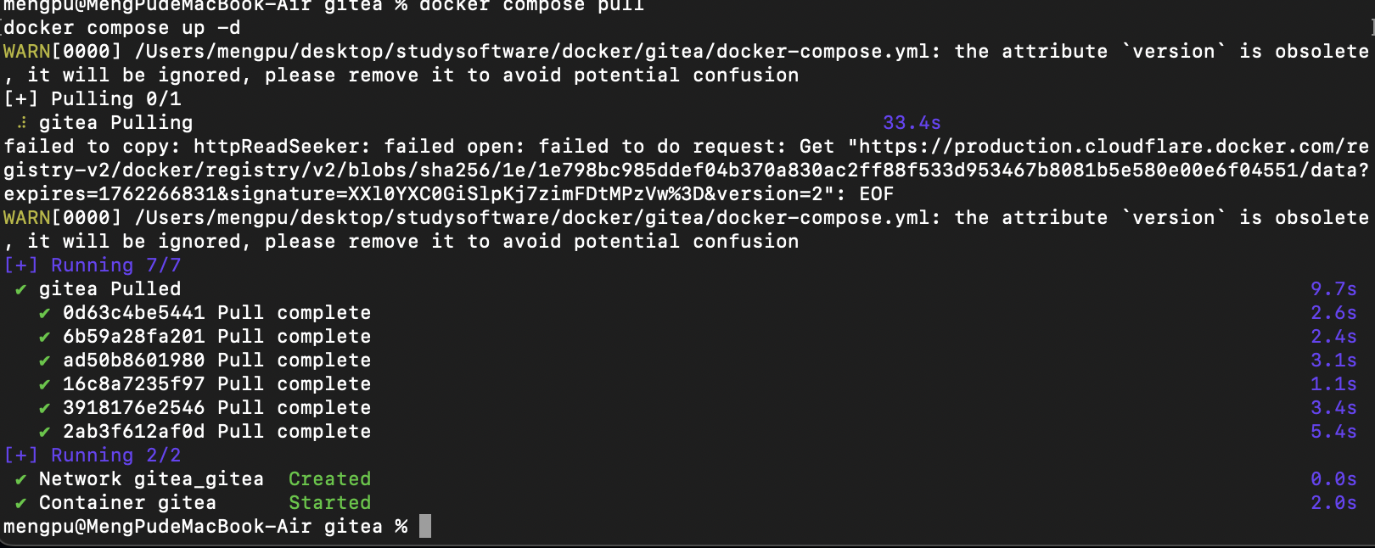
Docker image pulling process for Gitea container.
This screenshot shows the execution of 'docker compose up -d', which downloads the latest Gitea image and starts the service automatically within a Docker container.
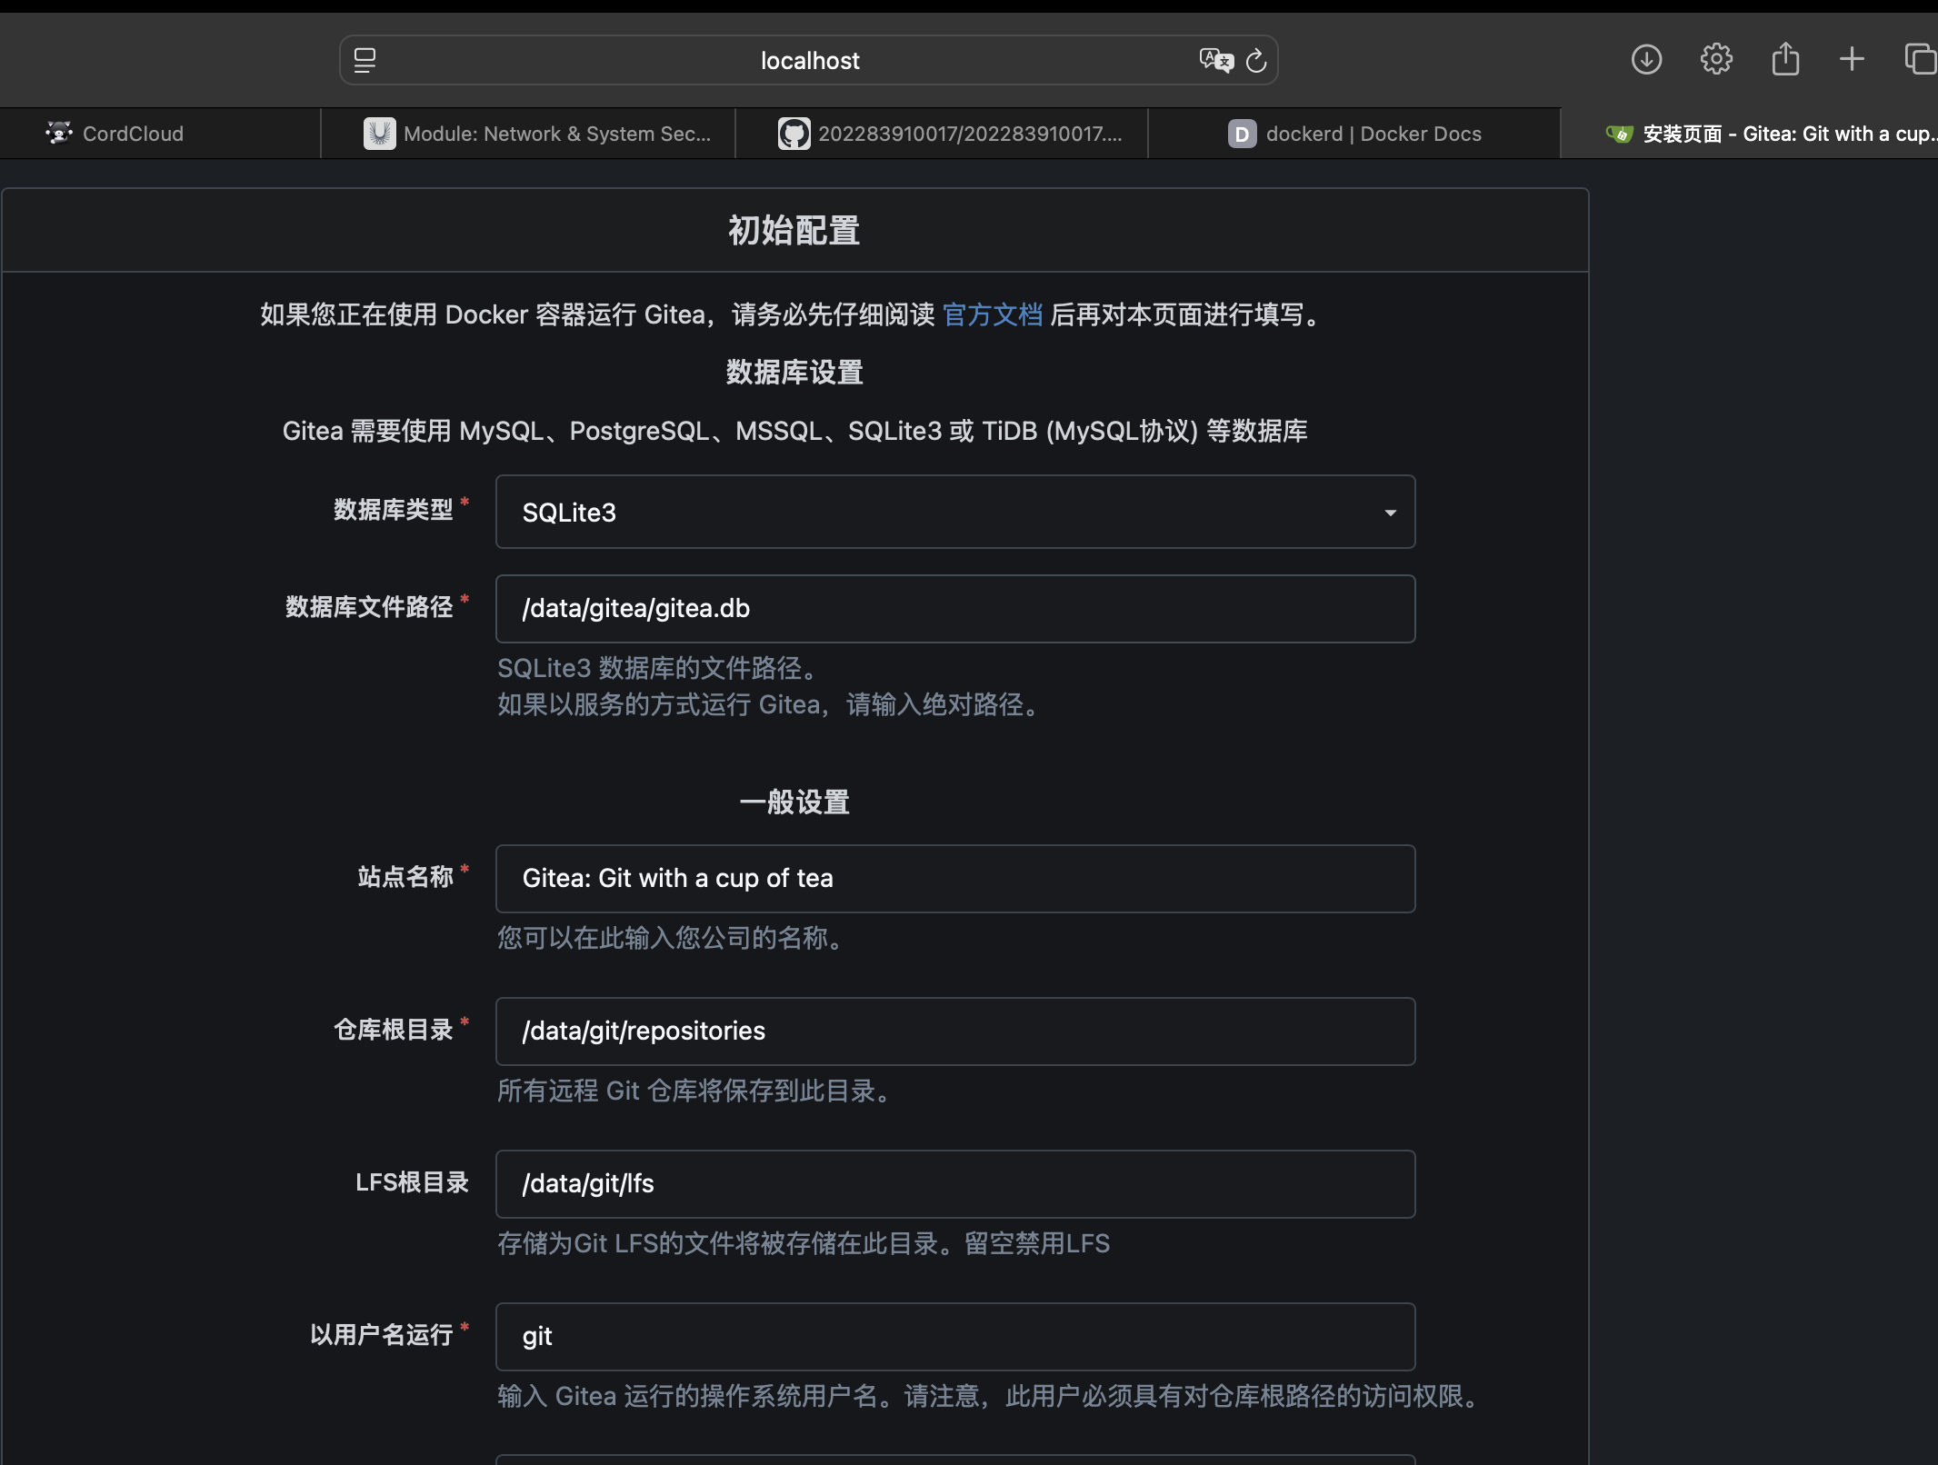
Initial configuration page of Gitea web interface.
The configuration interface allows specifying database type, file paths, and basic URL. This confirms that Gitea is successfully running on http://localhost:3000.
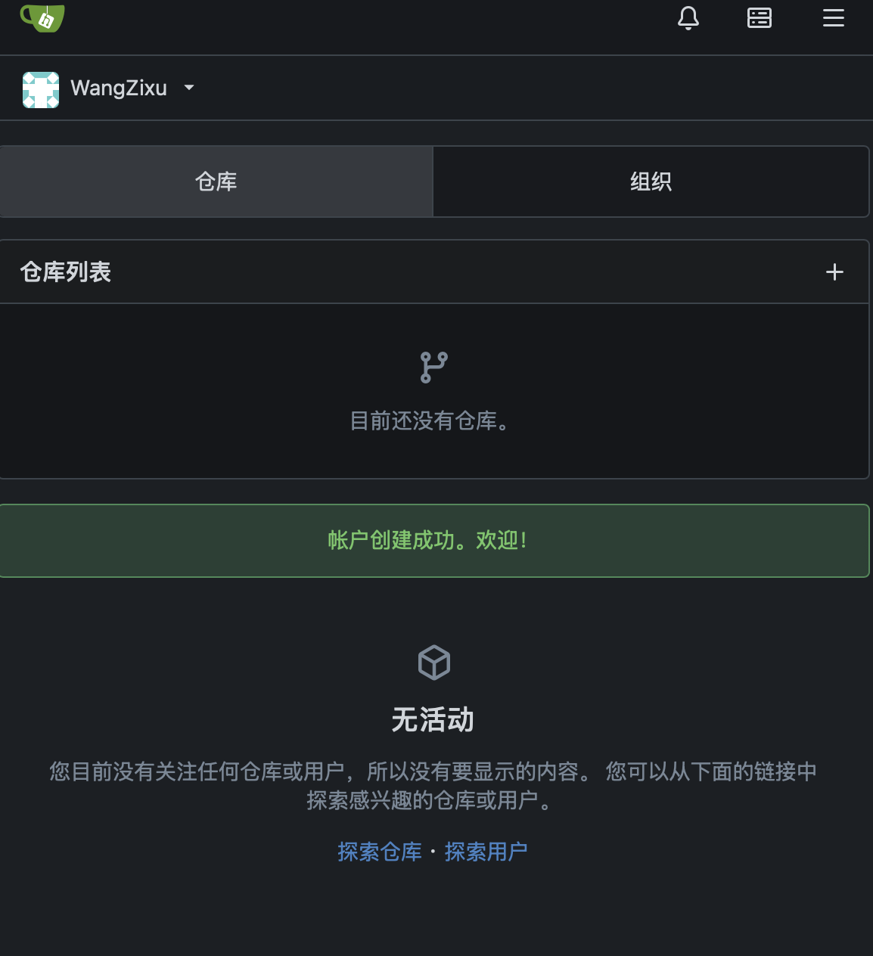
Successful Gitea installation confirmation.
After submitting the initial configuration, Gitea redirects to the login screen, proving that the setup process was completed successfully.

Step 3: Verify LFS and Upload Large File
Verified LFS support via configuration and uploaded a 1GB test file using Git LFS.
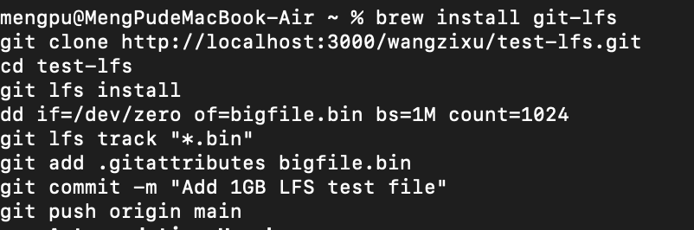
Commands for initializing Git LFS and uploading large file.
The commands 'git lfs install' and 'dd if=/dev/zero of=bigfile.bin bs=1M count=1024' create and upload a 1GB binary file to the local Gitea repository, validating LFS functionality.
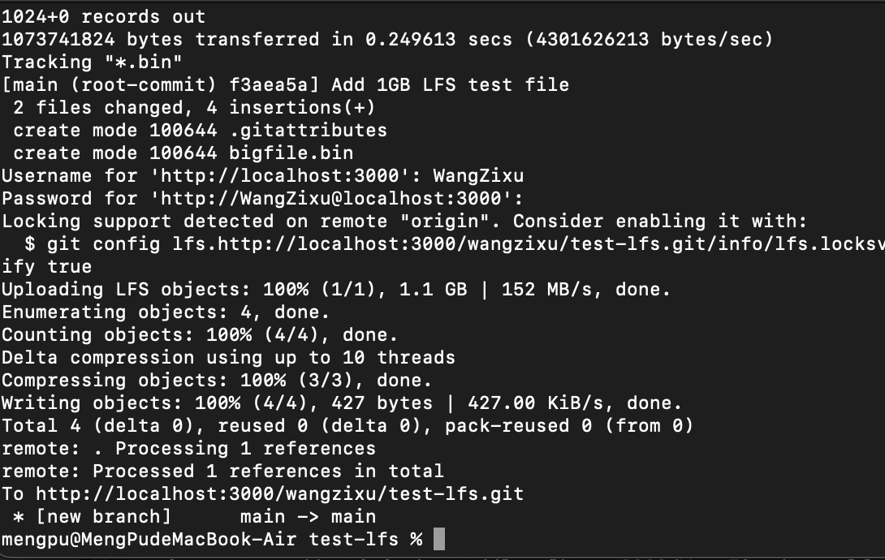
Terminal output showing LFS object upload completion.
The terminal output shows 'Uploading LFS objects: 100% confirming that the large file was uploaded successfully and handled by Git LFS instead of standard Git storage.
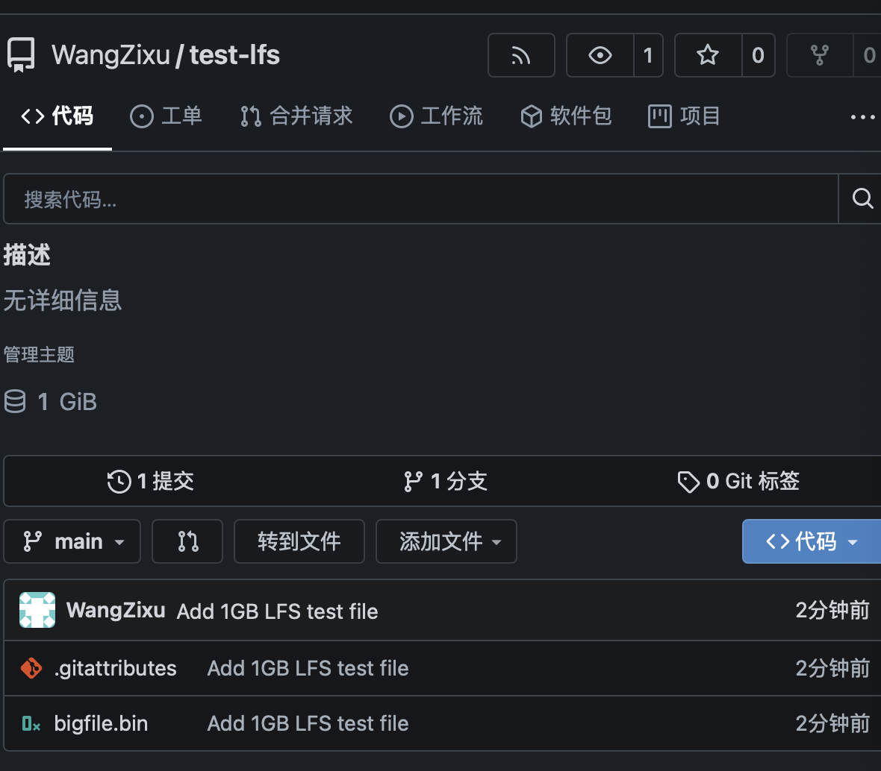
Repository view showing 1GB file successfully stored in Gitea.
The Gitea web interface displays the uploaded bigfile.bin file under the repository, indicating that LFS storage is enabled.

Step 4: Backup and Restore
Performed Gitea data backup using Docker exec and docker cp commands.
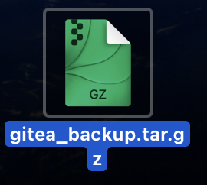
Backup archive created from Docker container.
Executed the commands 'docker exec -it gitea tar czf /data/backup.tar.gz /data' and 'docker cp gitea:/data/backup.tar.gz ~/Desktop/gitea_backup.tar.gz' to back up the Gitea configuration and repository data.

Step 5: Install Gitea without Docker
Installed native Gitea using Homebrew and verified independent execution.
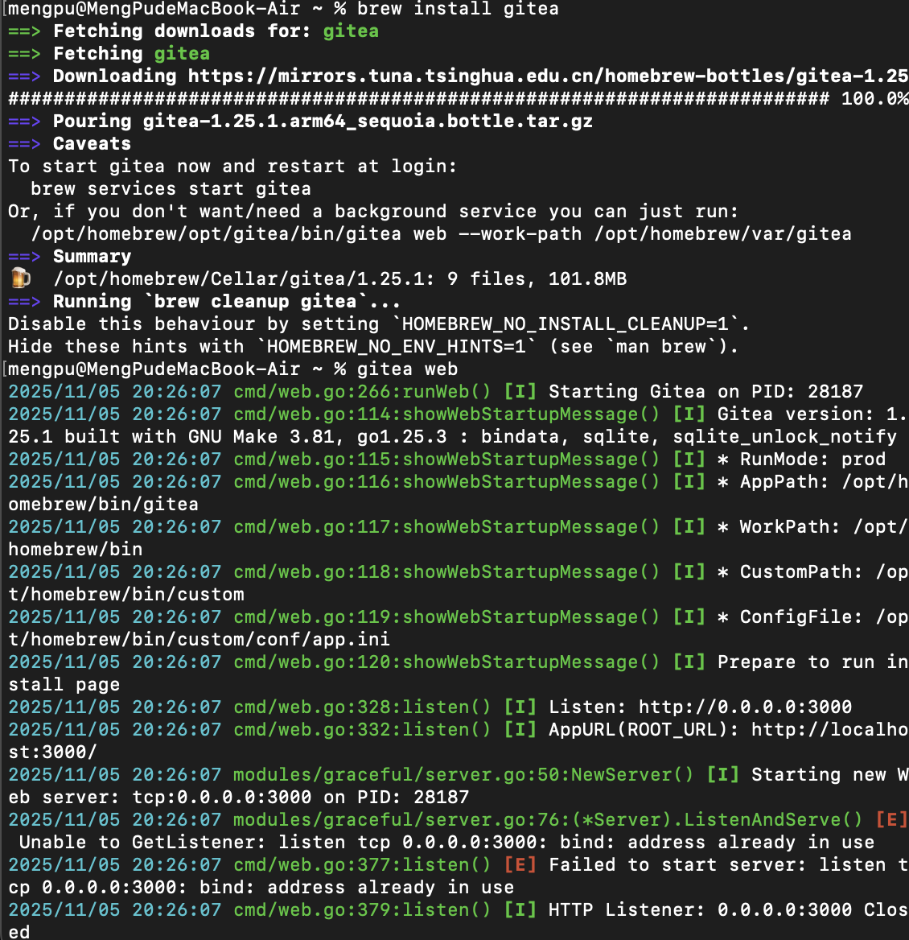
Native Gitea installation and web startup log.
Using the commands 'brew install gitea' and 'gitea web', Gitea was successfully installed and executed directly on macOS without Docker. The logs show successful startup on port 3000.

4. Conclusion
All steps were successfully completed. Gitea was deployed using Docker and verified with LFS enabled. A 1GB file was successfully uploaded using Git LFS.
Backup and restore operations were performed, and Gitea was also installed natively via Homebrew.

